NETWORK SUPPORT STRUCTURE for 3eministry.com
EVANGELIZE-EDUCATE-EQUIP

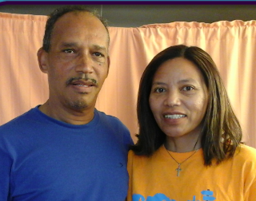
Willie & Tiana de Klerk
Missionaries

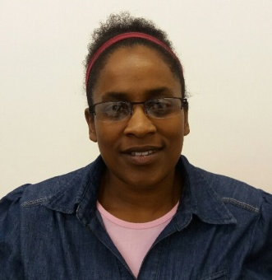
Bernadette Wagner
Prayer Partner

VOLUNTEERS
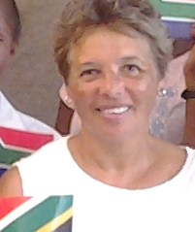

Rachel Jansen Joanna Herter

Tabea Stamminger Miriam (volunteer)

SENDING CHURCH: CCK Kenilworth – Cape Town
Website supporters: Klaus & Kathrin Neuwirth

